

**Name…………………………………………………………… ADM Number:……………..**

**School:…...……….............................. Candidate’s Signature……………...…………..**

**121/2**

**Mathematics Alt.A**

**FORM FOUR.**

**JULY 3RD 2024.**

**2 ½ Hours.**

**URANGA MATHEMATICS ASSOCIATION-2024.**

**Kenya Certificate of Secondary Education**

**MATHEMATICS 121/2**

**FORM FOUR**

**TIME: 2 ½ HOURS**

**INSTRUCTIONS TO CANDIDATES:**

* Write your name, school, admission number and sign in the spaces provided above.
* This paper contains **TWO** sections: Section **I** and Section **II**.
* Answer **ALL** the questions in Section **I** and **FIVE** questions from section **II**.
* All answers and working **MUST** be written on the question paper in the spaces provided below each question.
* Marks may be given for correct working even if the answer is wrong.
* Non-programmable silent electronic calculators and KNEC Mathematical tables may be used, except where stated otherwise.

**FOR EXAMINERS USE ONLY**

**SECTION I**

|  |  |  |  |  |  |  |  |  |  |  |  |  |  |  |  |  |
| --- | --- | --- | --- | --- | --- | --- | --- | --- | --- | --- | --- | --- | --- | --- | --- | --- |
| **1** | **2** | **3** | **4** | **5** | **6** | **7** | **8** | **9** | **10** | **11** | **12** | **13** | **14** | **15** | **16** | **Total** |
|  |  |  |  |  |  |  |  |  |  |  |  |  |  |  |  |  |

**SECTION II**

**Grand Total**

|  |  |  |  |  |  |  |  |  |
| --- | --- | --- | --- | --- | --- | --- | --- | --- |
| **17** | **18** | **19** | **20** | **21** | **22** | **23** | **24** | **Total** |
|  |  |  |  |  |  |  |  |  |

*This paper consists of 15 printed pages. Candidates should check to ascertain that all pages are printed as indicated and that no questions are missing.*

**SECTION I** (50Marks) **Answer** all **questions in this section in the spaces provided.**

1. A dealer has two types of grades of tea, A and B. Grade A costs shs. 140 per kg while grade B

costs shs.160 per kg. If the dealer mixes A and B ratio 3:5 to make a brand of tea which he

sells at shs.180 per kg, calculate his percentage profit (3 marks)

2. Solve for x in the equation 2 (4 marks)

3. Make c the subject of the formula (3 marks)

=

4. A quadratic curve cuts the x – axis at points (-2, 0) and (3, 0). Find the equation of this curve

in the form a $x^{2}$ + by = c where a, b and c are integers. (3 marks)

5. The equation of a circle is 2x2  2y2 16x 12 y  22  0 . Determine the centre and radius of

the circle. (3 marks)

6. Expand up to the term in x3. Hence use your expansion to estimate $({2.09)}^{6}$

(3 marks)

7. The diameter of a spherical ball is measured as 14cm, correct to the nearest centimeter.

Determine, to 2 decimal places, the percentage error in calculating the volume of the ball.

(3 marks)

8. Given that O is the origin and **OA** = 2**i** + 2**j** – 4**k** and **OB** = 6**i** + 10**j** + 2**k**. If R divides AB

externally in the ratio 3:1, find **OR** in terms of **i** , **j** and **k**. (3 marks)

9. Calculate the quartile deviation in 18, 9, 14, 20, 23, 12, 16 (3 marks)

10. Solve for the exact value of x in the equation. (3 marks)  
 2x +5 = 1 + 24

11. Evaluate (3 marks)

12. In the figure below QT is a tangent to the circle at Q. PXRT and QXS are straight lines. PX =

6 cm, RT = 8 cm, QX = 4.8 cm and XS = 5 cm.  
 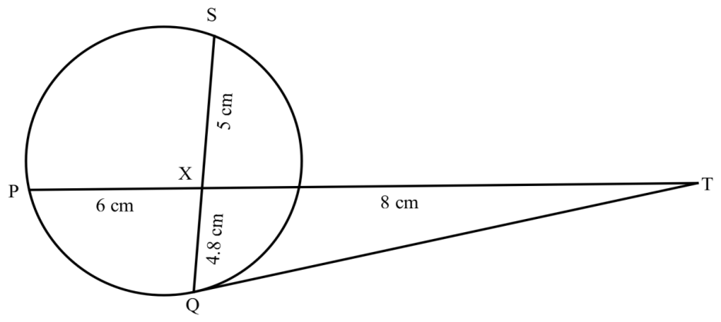

Find the length QT. (3 marks)

13. The table below shows the relationship between the quantities P and Q.

|  |  |  |  |  |  |  |  |
| --- | --- | --- | --- | --- | --- | --- | --- |
| P | 0 | 1 | 2 | 3 | 4 | 5 | 6 |
| Q | 2.4 | 5.2 | 8.4 | 11.6 | 14.0 | 17.6 | 20.4 |

1. On the grid provided, draw a line of best fit. (2 marks)

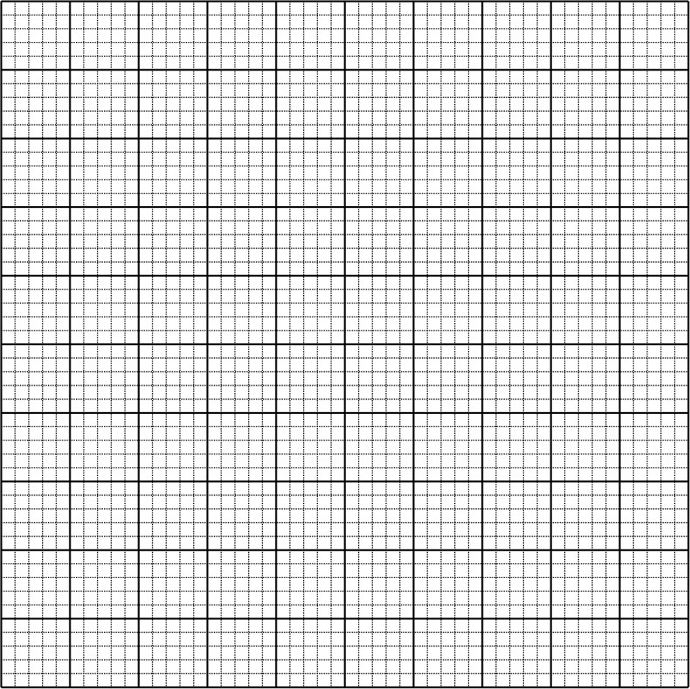

1. Using the graph, find the law connecting P and Q (2 marks)

14. Radido bought a ‘*tuk – tuk’* whose cash price is kshs 500,000. He made a down payment of

kshs. 140,000 and paid monthly installments of kshs. 25, 000 for two years. Calculate the

monthly rate at which compound interest was charged. (3 marks)

15. A transformation is represented by the matrix $\left[\begin{matrix}1 & 3 \\ 4 & 2\end{matrix}\right]$. This transformation maps a triangle

ABC of the area 12.5cm2 onto another triangle $A^{1}B^{1}C^{1}$. Find the area of triangle $A^{1}B^{1}C^{1}$

(3 marks)

16. Without using tables or calculators, express $\frac{\sqrt{3}+sin{30}^{0}}{2-tan{60}^{0}}$ in the form a + b $\sqrt{c}$

(3 marks)

**SECTION II (50marks)**

**Answer any five questions in this section.**

17. A married couple intends to have 3 children. They consult an expert who tells them that the

probability of a male birth is 0.55

(a) Draw a tree diagram to represent this occurrence. (2 marks)

(b) Find the probability that   
(i) All the three children will be female. (2 marks)

(ii) At least a male is born. (2 marks)

(iii) At least 2 will be females, giving your answer to 3 s.f. (4 marks)

18.A trader is required to supply two types of sweaters, type **A** and type **B**. The total number of

sweaters must be more than 400. He has to supply more of type A than type **B** sweaters.

However the number of type **A** sweaters must not be more than 300 and the number of type **B**

sweaters must not be less than 80. Let **x** be the number of type **A** sweaters and y be the

number of type **B** sweater.  
(a) Write down in terms of **x** and **y** all the linear inequalities representing the information above.

(4 marks)

b) On the grid provided, draw the inequalities and shade the unwanted regions. (4 marks)



c) The profits were as follows; Types A: Sh.600 per sweater and Type B: Sh. 400 per sweater.

Use the graph to determine the number of sweaters of each type that he should make to

maximize the profit. Hence calculate the maximum possible profit. (2 marks)

19. The table shows income tax rates for a certain year.

|  |  |
| --- | --- |
| Monthly taxable pay K£ | Rate of tax in Ksh. Per K£ |
| 1 – 434  435 – 866  867 – 1298  1299 – 1730  OVER 1730 | 2  3  4  5  6 |

A company employee earns a monthly basic salary and is given taxable allowances amounting to Ksh 10,480. If the employees’ tax on the 5th band is ksh 3,420;

1. Calculate the employee’s monthly taxable income tax in K£. (2 marks)
2. The employee is entitled to personal tax relief of ksh. 1056 per month. Determine the net tax (4 marks)

1. In a certain month, the employee received a 25% increment in his basic salary. Calculate his net monthly pay (4mrks)

20. Given that y = 2 sin $x^{0}$ and y = cos ${ (x+10)}^{0}$

1. Complete the table below correct to 2decimal places (2marks)

|  |  |  |  |  |  |  |  |  |  |  |  |  |  |
| --- | --- | --- | --- | --- | --- | --- | --- | --- | --- | --- | --- | --- | --- |
| X | 0 | 30 | 60 | 90 | 120 | 150 | 180 | 210 | 240 | 270 | 300 | 330 | 360 |
| 2 $sinx^{0}$ | 0 |  | 1.73 |  |  | 1 | 0 |  | -1.73 |  | -1.73 |  |  |
| cos ${\left(x+10\right)}^{0}$ | 0.98 |  |  | -0.17 |  |  | 0.98 | -0.77 |  |  | 0.64 |  | 0.98 |

1. On the same axes, draw the graphs y = 2 ${sinx}^{0}$ and y =cos $({x+10)}^{0}$ for $0^{0}≤x≤{360}^{0}.$ Using the scale: 1cm rep ${30}^{0}$ on the horizontal axis and 2cm rep 1cm unit on the vertical axis. (5 marks)



(c)Use your graph to find:

1. The range of values of x for which 2 ${sinx}^{0}$ $≥{cos\left(x+10\right)}^{0}$ (2 marks)
2. The period of y = 2 (1 mark)

21. The positions of two towns on the surface of the earth are given as A ( ${45}^{0}s,{20}^{0}w$) and B ${ (45}^{0}S,{80}^{0}E)$.

Find:

1. The difference in their longitude (2 marks)
2. The distance between the two towns in :
3. Kilometers (R = 6370km, $π=\frac{22}{7}$) (3 marks)
4. Nautical miles (2 marks)

1. The local time in town A when it is 8.20am in B (3 marks)

22. Construct a triangle XYZ in which XY=7cm, YZ=7.2cm and XZ=4.2cm. Measure angle

XYZ

(3 marks)

A point R is located inside triangle XYZ such that:

1. XR $>2cm$ (1mrk)
2. R is closer to X than Y
3. R is closer to XY than YZ
$<XRY ≥{120}^{0}$

5. Shade he locus of R (7 marks)

23. The figure below shows a square based pyramid ABCDV with AD = DC =6 cm and

OV = 10 cm

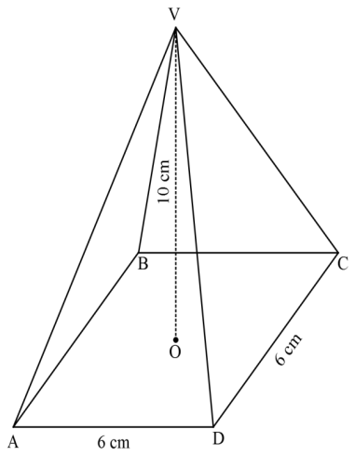

(a) State the projection of VA on base ABCD. (1 mark)

(b)Find;

(i) The length VA. (3 marks)

(ii) The angle between VA and ABCD. (2 marks)

(iii) The angle between VDC and ABCD (2 marks)

(iv) The volume of the pyramid (2 marks)

24. In an arithmetic progression (A.P), the 4th term and 9th term are 30 and 45 respectively.

1. Find the first term and common difference of the A.P. (3 marks)
2. The second, sixth and twelfth terms of the above A.P are the first three consecutive terms of a geometric progression (G.P). Find:

(i) The common ratio. (3 marks)

(ii) The fourth term of the G.P. (2 marks)

(iii) The sum of the first 5 terms of the G.P. (2 marks)